Alexander van Twisk
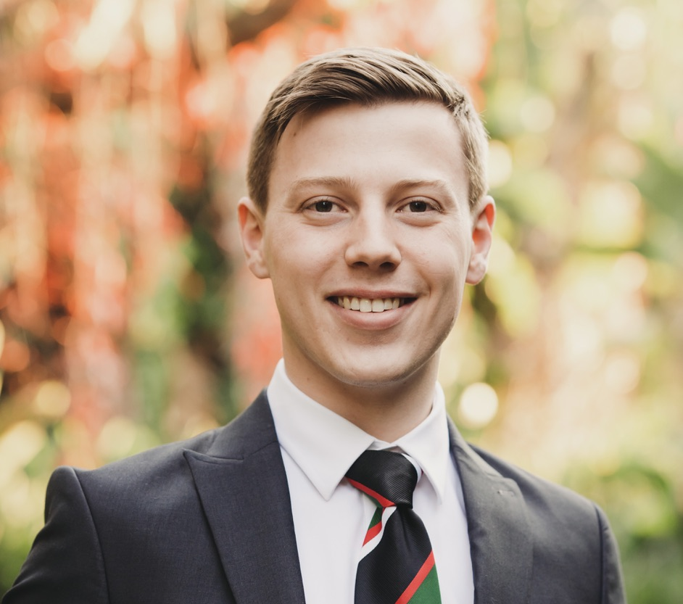

Biosketch:
Alexander van Twisk is a Master’s student in Biostatistics at Stellenbosch University and a Junior Biostatistician at Scigenix, a clinical research organisation involved in several clinical trials across the world. Originally from Pretoria, he attended Pretoria Boys High School, where he developed an early love for mathematics — a passion that has shaped both his academic and professional journey.
He earned a Bachelor of Science in Applied Mathematics (2021), followed by a Postgraduate Certificate in Education (2022, with distinction), and later a BSc Honours in Biostatistics (2023, with distinction), all from the University of Pretoria. These qualifications laid the foundation for his dual interests in quantitative science and effective scientific communication.
Alexander’s professional focus lies at the intersection of biostatistics, data science, and AI automation. His current MSc research explores Bayesian methods for interval-censored survival data, while his work at Scigenix involves statistical programming, biostatistics services, and quality control for clinical trials.
He is particularly passionate about statistical programming in R, reproducible research, and the safe, efficient use of AI tools to streamline biostatistical workflows. With a strong grounding in both mathematics and education, Alexander aims to bridge rigorous statistical thinking with clear, accessible communication — advancing the role of data science in improving public health and clinical research.

